Church Membership Form
To be a member of a church is to make a promise to live according to the Bible and to support the work of the congregation. In the Bible, this is called a covenant. Every Christian is part of the church as an organism (the spiritual body of Christ) but only through a covenant can someone be part of the church as an organisation. At St Clement’s, we seek to be a community not for ourselves but for others. To become a member therefore means becoming a provider of God’s love and care for others.
Please fill in the below form for enrolment on the Church Electoral Roll of the Parish of St Clement’s Higher Openshaw.
Full Name

Address

Contact telephone number

Contact email address

I declare that:
- I am baptised and am aged 16 or over
- I live in the parish or have habitually attended public worship during the period of sixth months prior to my enrolment
- I believe the doctrines of Christianity, expressed in The Apostles’ Creed, The Ten Commandments and The Lord’s Prayer
- I believe that the Bible is the Word of God and has ultimate authority in all matters of faith and conduct
I declare that the above is true and apply for inclusion on the Church Electoral Roll of the parish.
Signed:
Date:

Data Consent Form
I allow any photographs or videos which I appear in to be used in/on St Clement’s publications, website and social media:
☐ Yes
☐ No
For parents/legal guardians only:
I allow any photographs or videos which my child(ren) appear(s) in to be used in/ on St Clement’s publications, website and social media:
☐ Yes
☐ No
Printed name(s) of child(ren):
Mailing list
I would like to be added to the St Clement’s Church Mailchimp mailing list in order to receive the weekly Community Life email. I consent to my email address being added to this list.
☐ Yes
☐ No
Signed:
Date:
Please return your completed form to the church office.

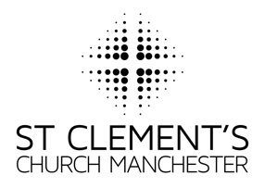

St Clement’s Church Office
hello@stclementschurchmanchester.org
07737915353

www.stclementschurchmanchester.org

